Unix command
1. pwd

Print working directory
it print the path of the working directory, starting from the root.
Syntax: pwd
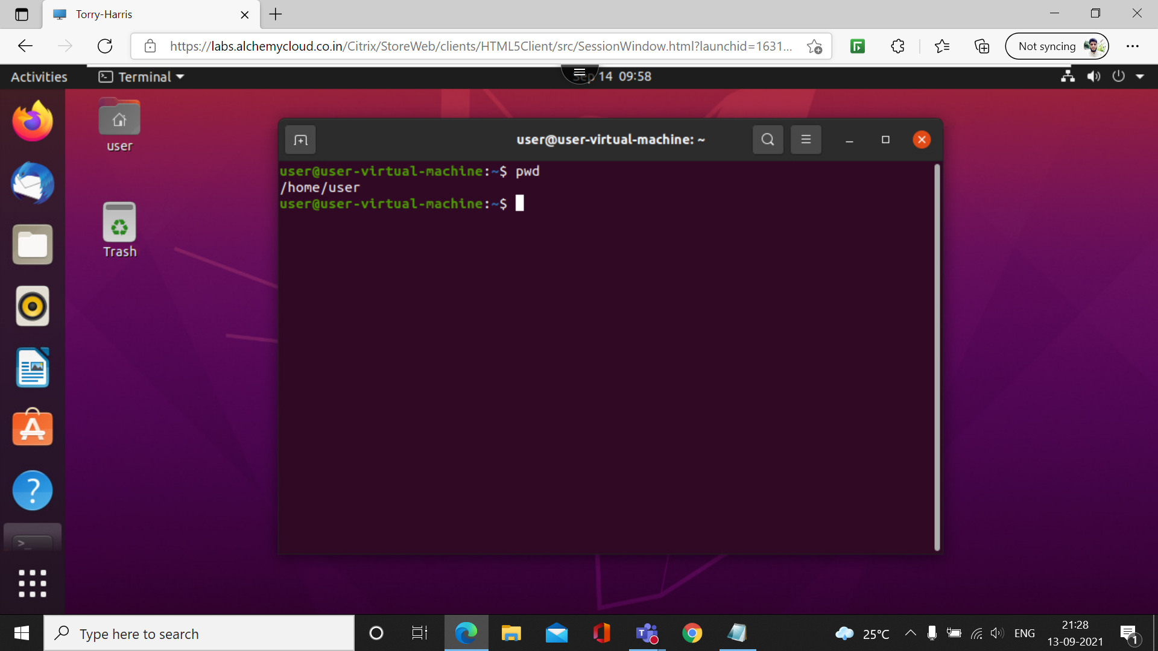

2. ls

list the names of files files in a particular unix directory. if you type the ls command with no parameters or qualifiers,the command display the files listed in the current directory

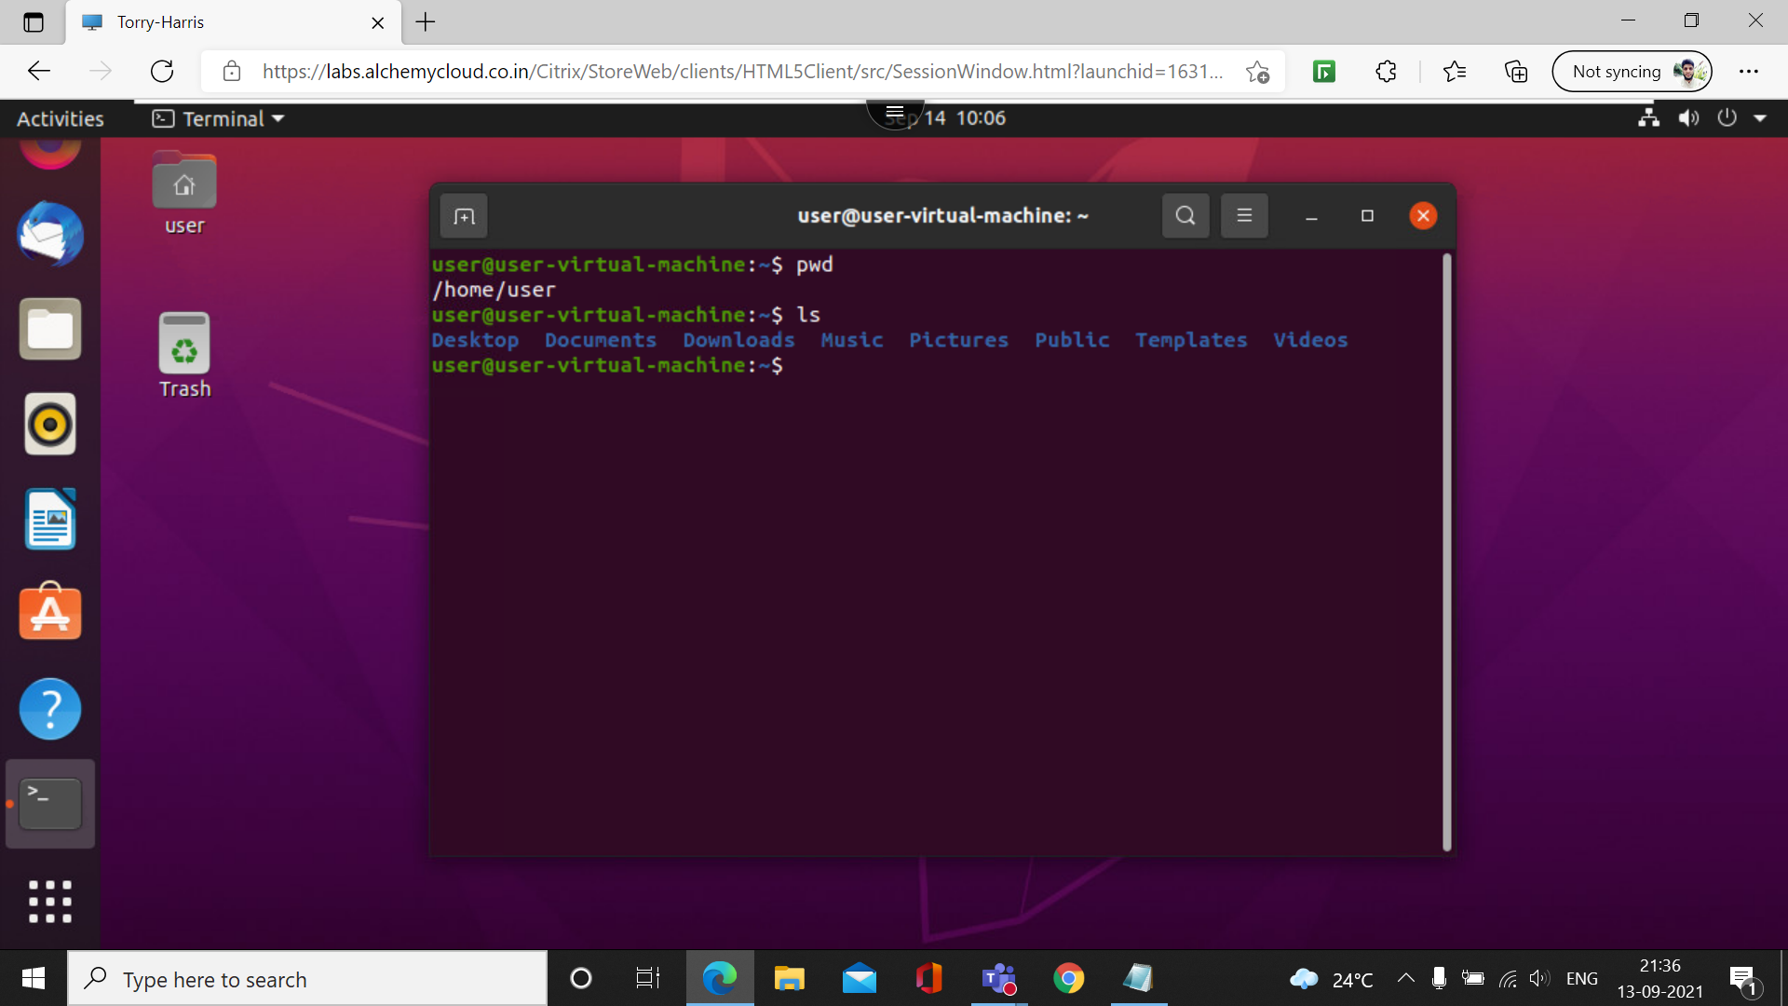

3. ls -l
Gives a long listing of the files in your directory. in addition to the file name, long listing shows protection information ,file owner, number of character in file, and date and time of the last change to the file.

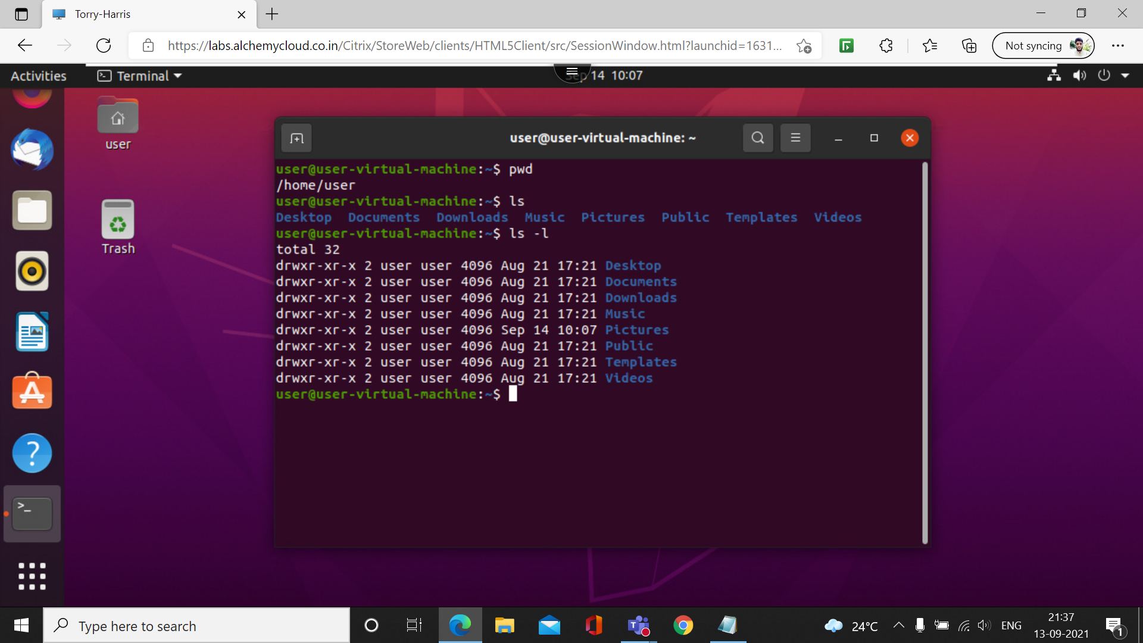

4. ls -a
this command will enlist the whole list of the current directory including the hidden files.
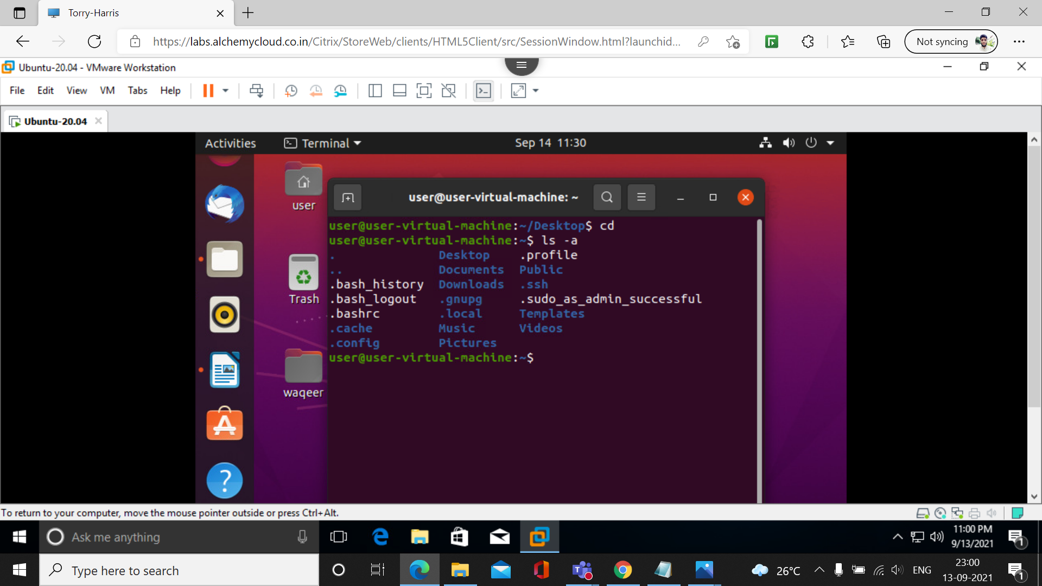

5. Clear
clear is a computer operating system command which is used to bring the command line on the top of the computer termunal.

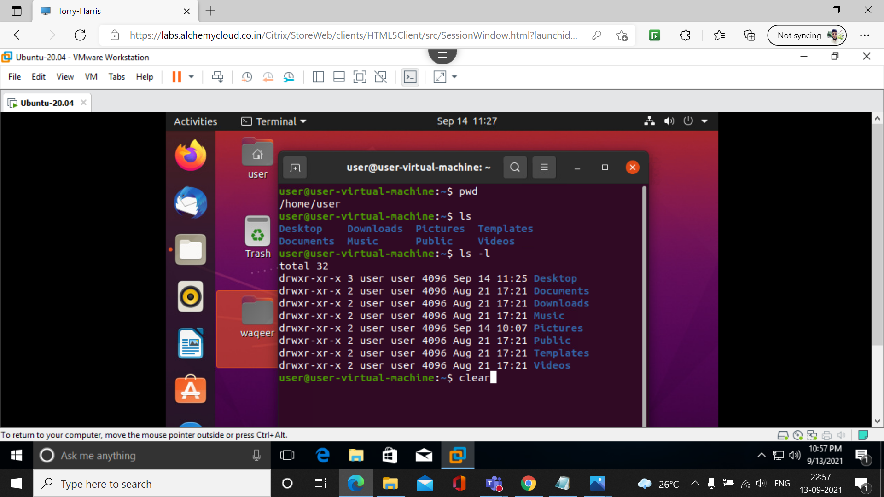

6. cd

The cd command can be used to either change to a directory that is relative to the location of the current working directory or to an absolute location in the filesystem.
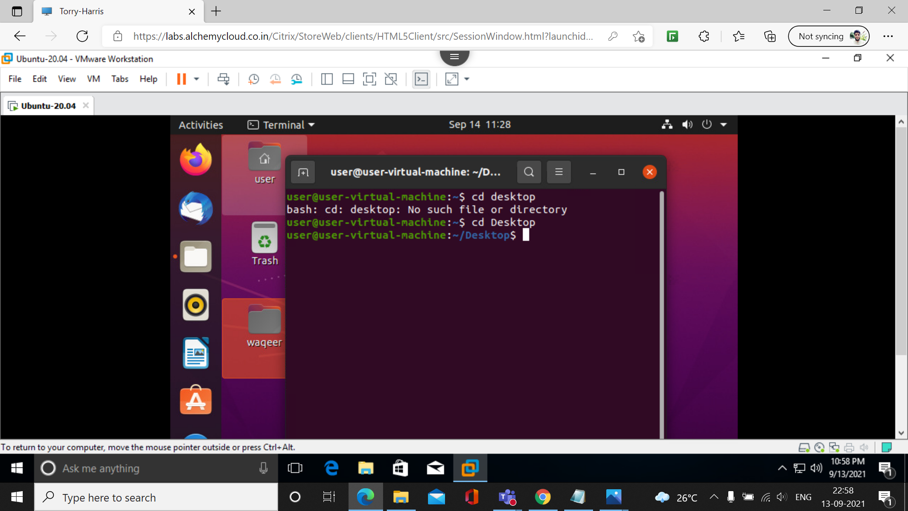

7. cd ..

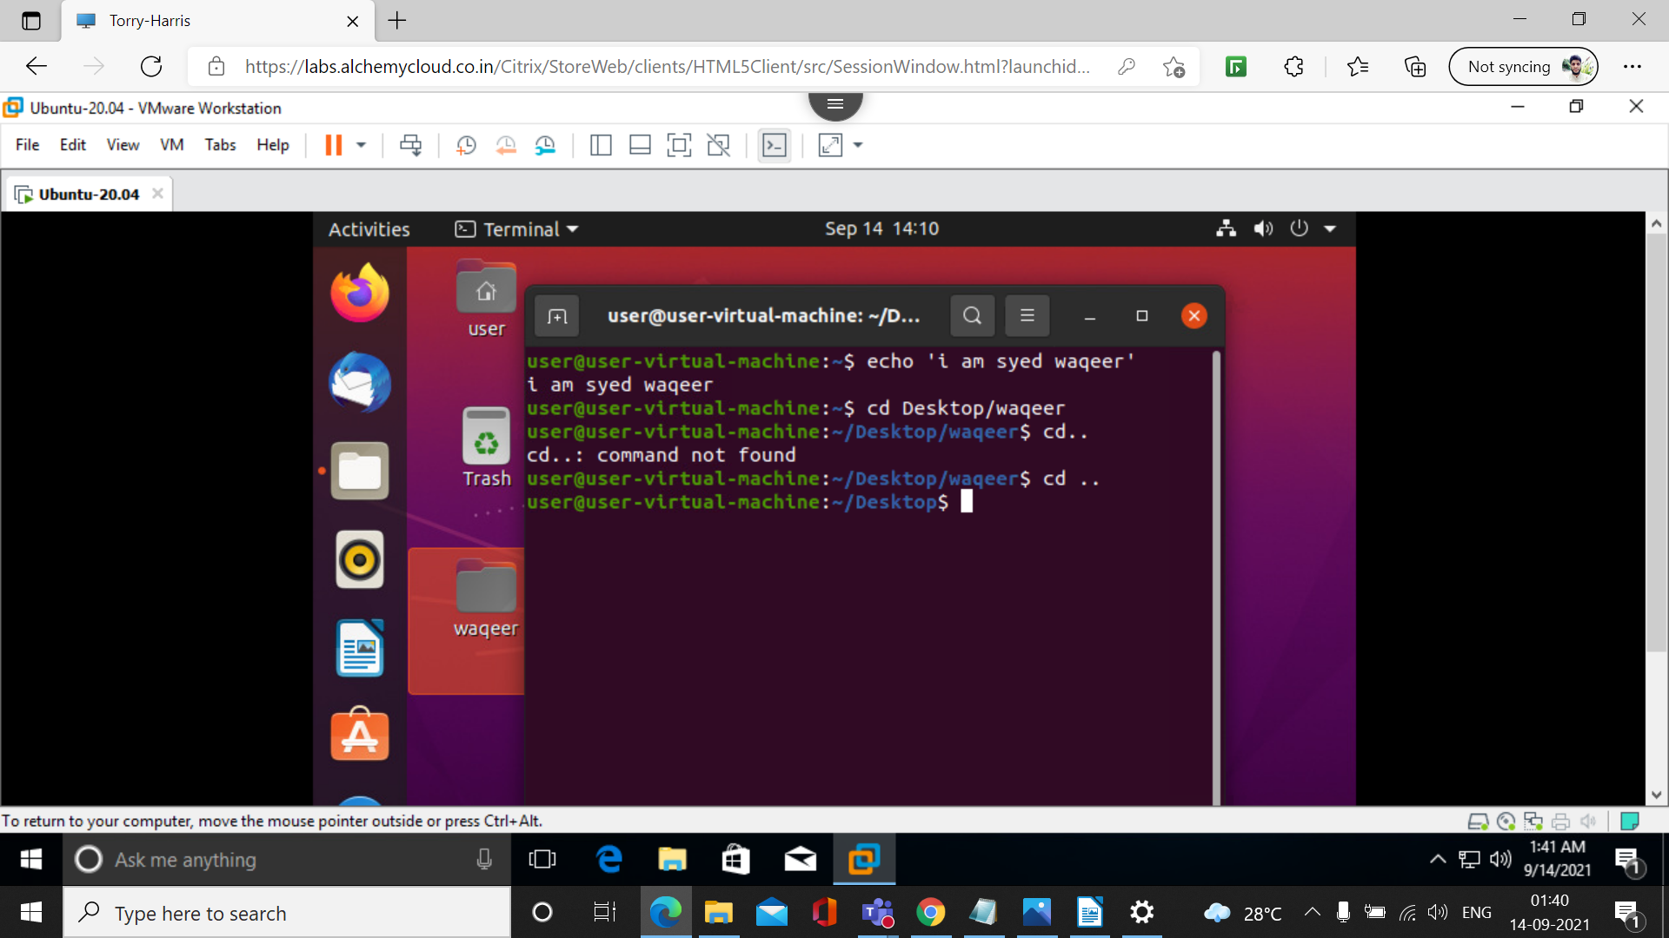
8. cd /
To navigate directory to entire system's root directory from current working directory

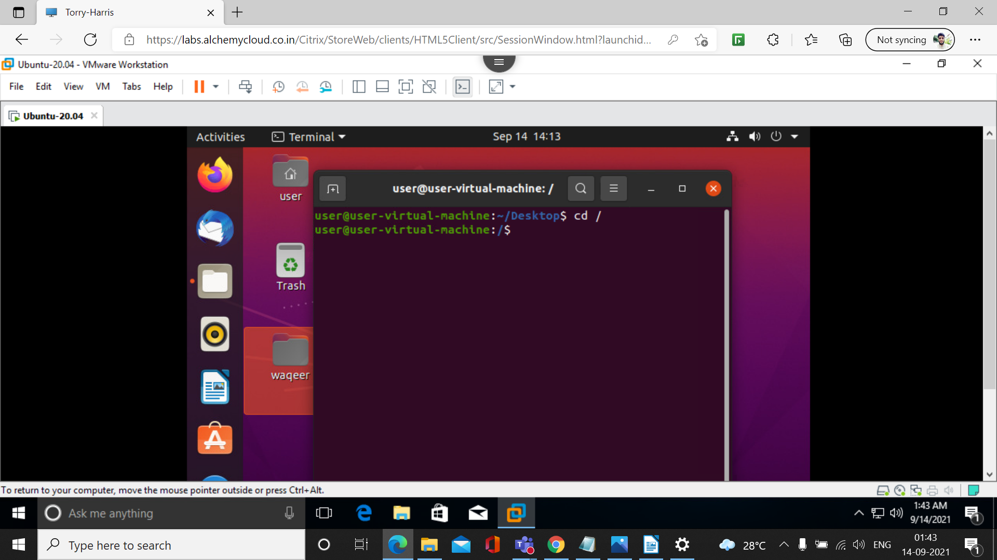

9. ls -f
The Linux ls command allows you to view a list of the files and folders in a given directory.
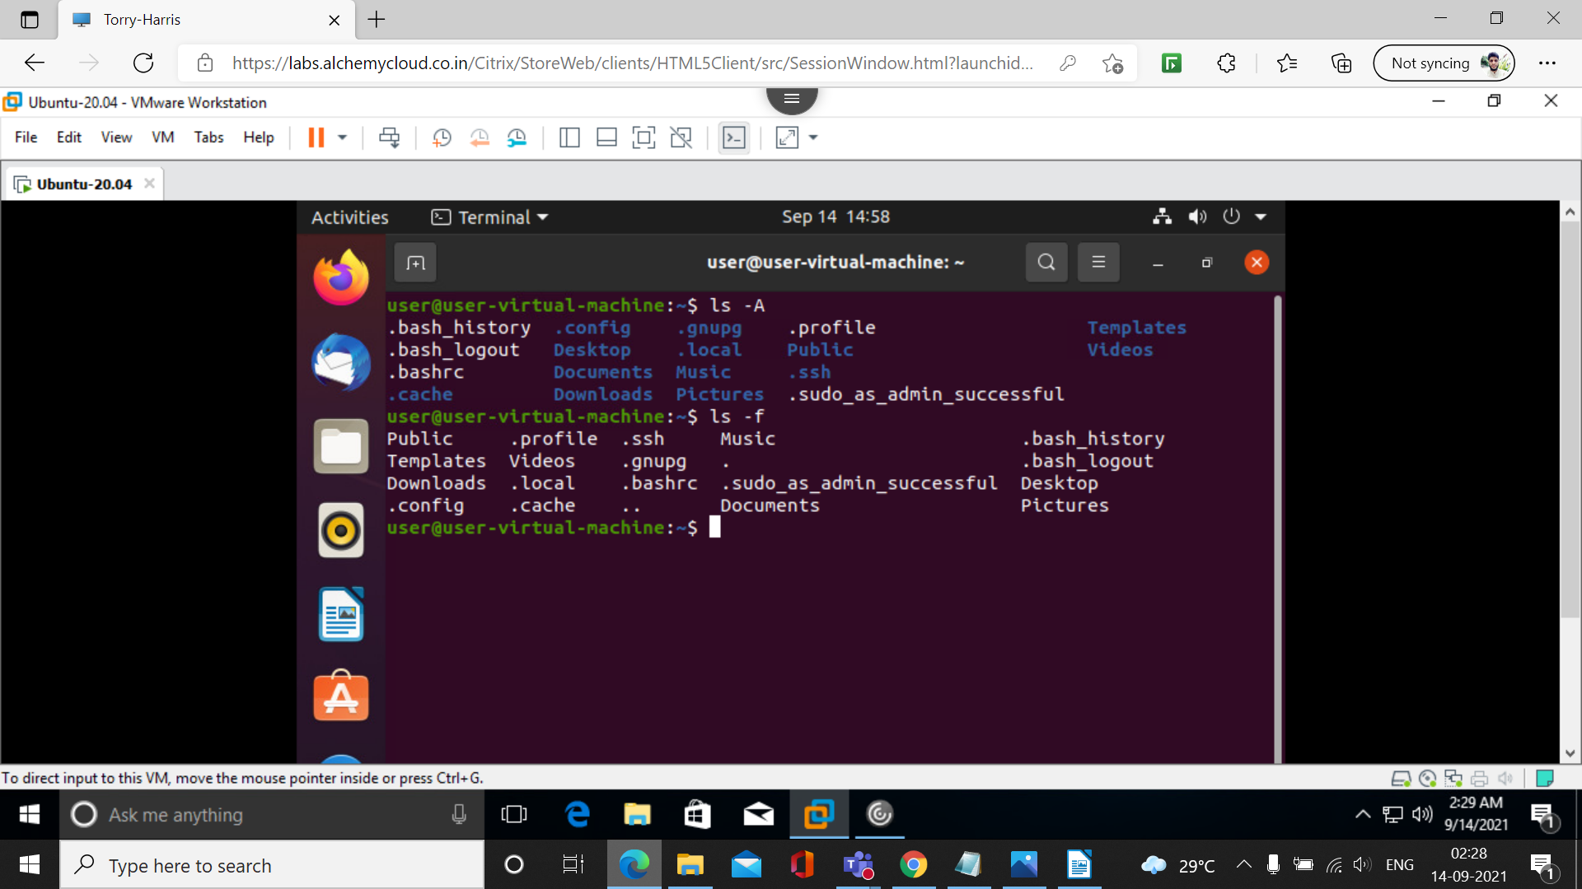
10. exit
exit command in linux is used to exit the shell where it is currently running.

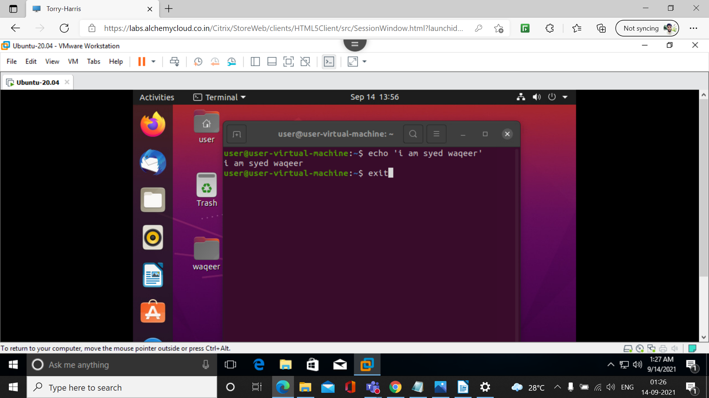

11. cat

The cat command display file contents to a screen. Also, you can use cat command for quickly creating a file.
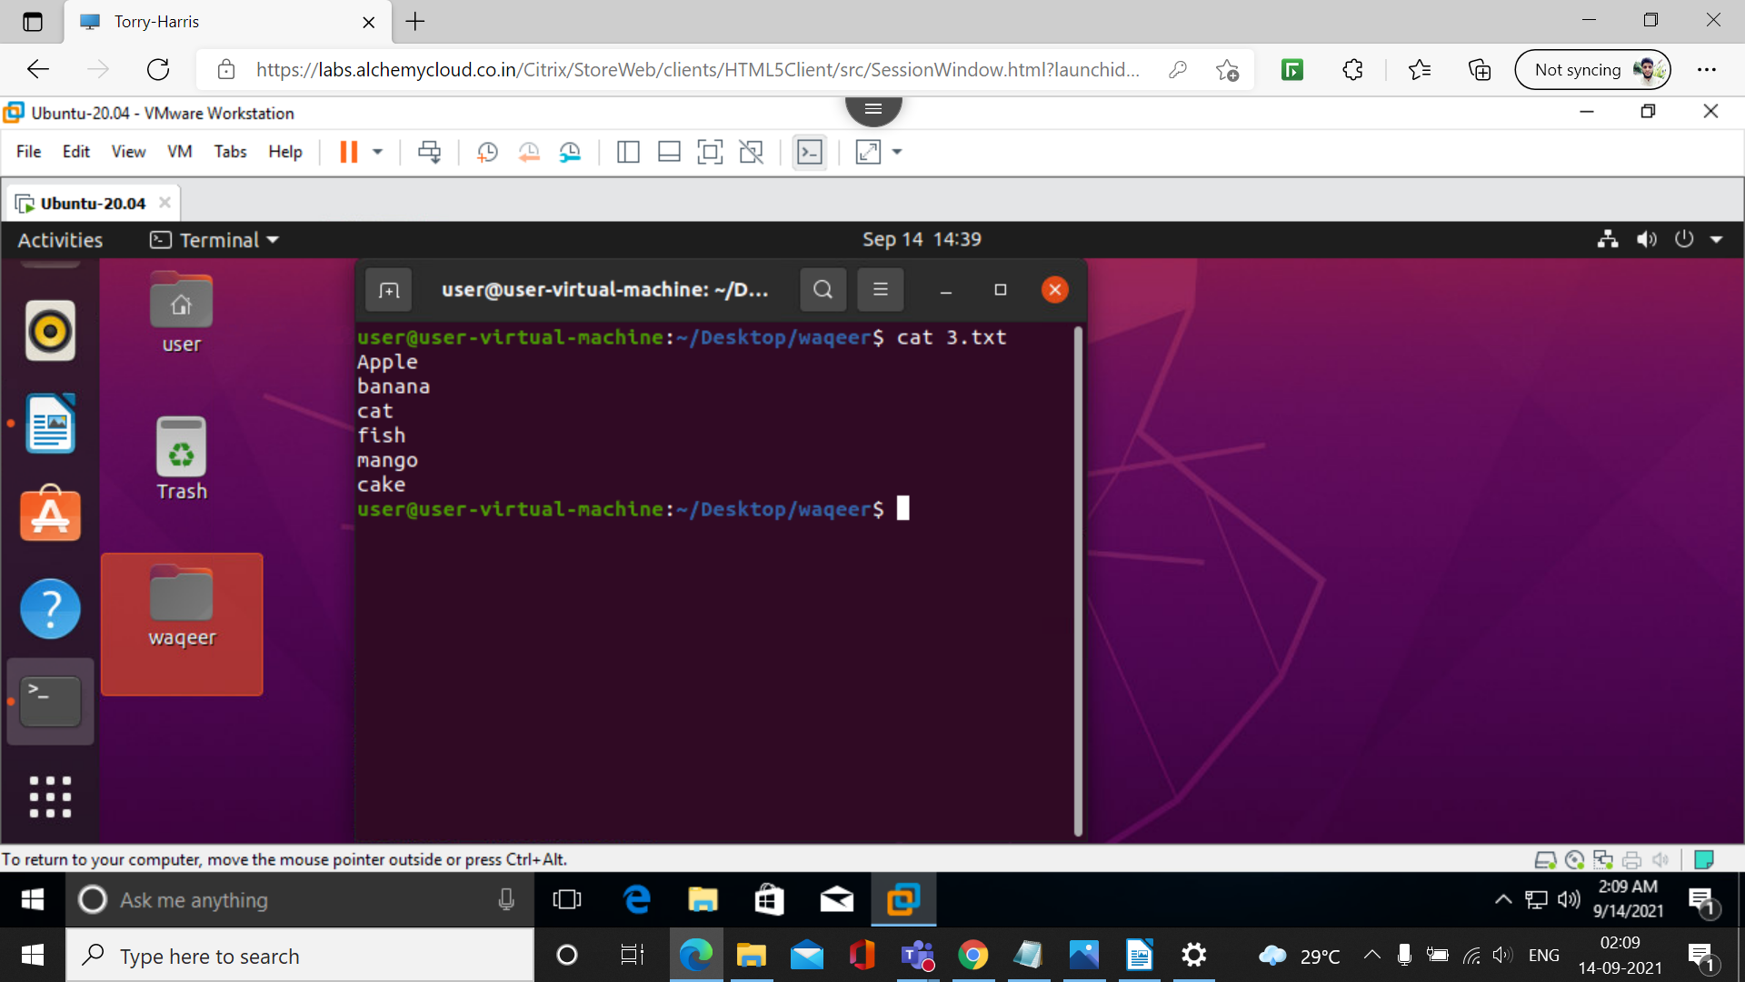

12. man
man command in Linux is used to display the user manual of any command that we can run on the terminal. It provides a detailed view of the command which includes NAME, SYNOPSIS, DESCRIPTION, OPTIONS, EXIT STATUS, RETURN VALUES, ERRORS, FILES, VERSIONS.

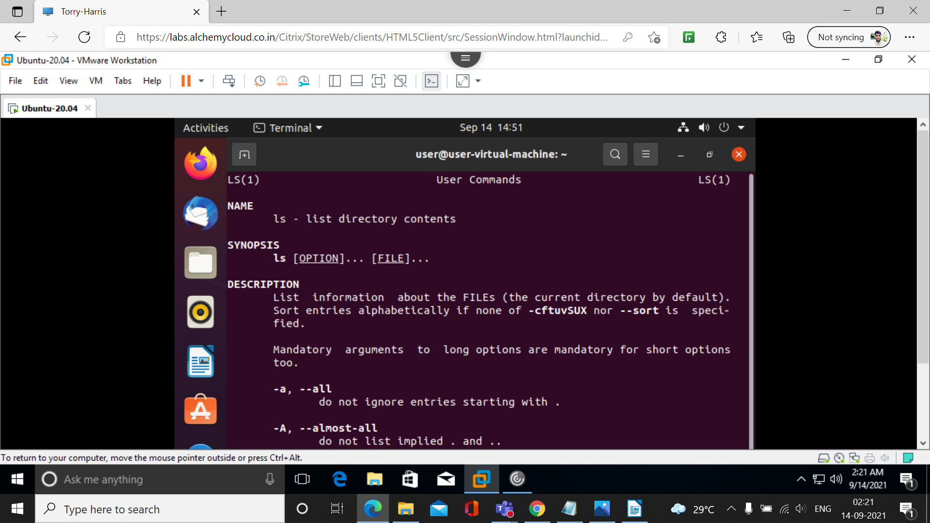

13. mv
This command is to rename the directory
syntax mv ‘present filename’ ‘new filename’
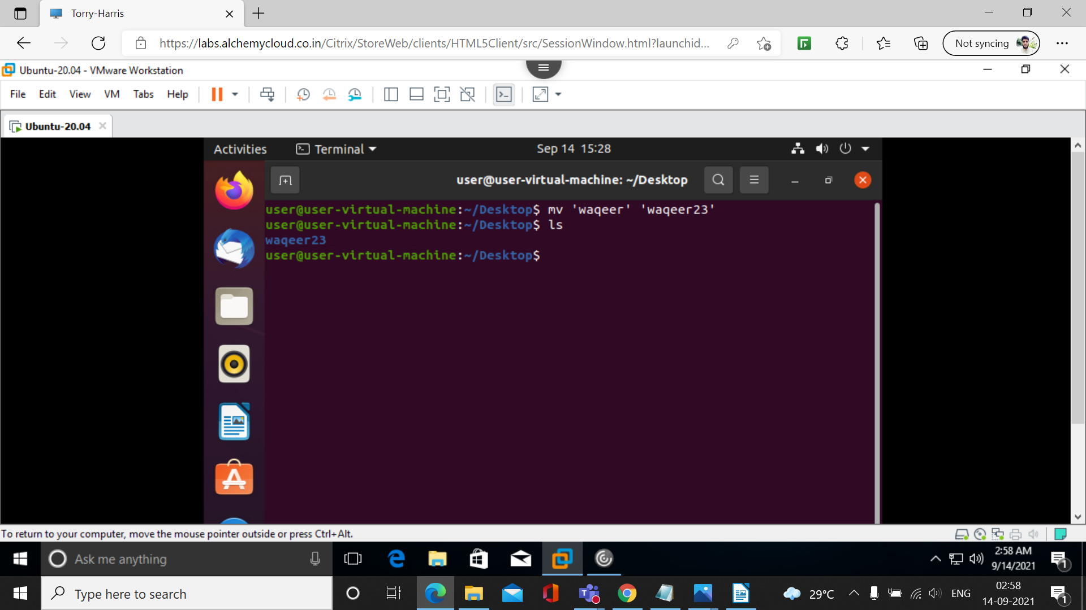

14. echo

echo command in linux is used to display line of text/string that are passed as an argument . This is a built in command that is mostly used in shell scripts and batch files to output status text to the screen or a file.

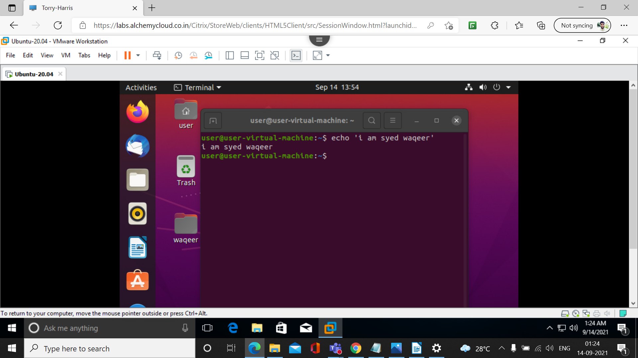
15. mkdir
mkdir command in Linux allows the user to create directories This command can create multiple directories at once as well as set the permissions for the directories.

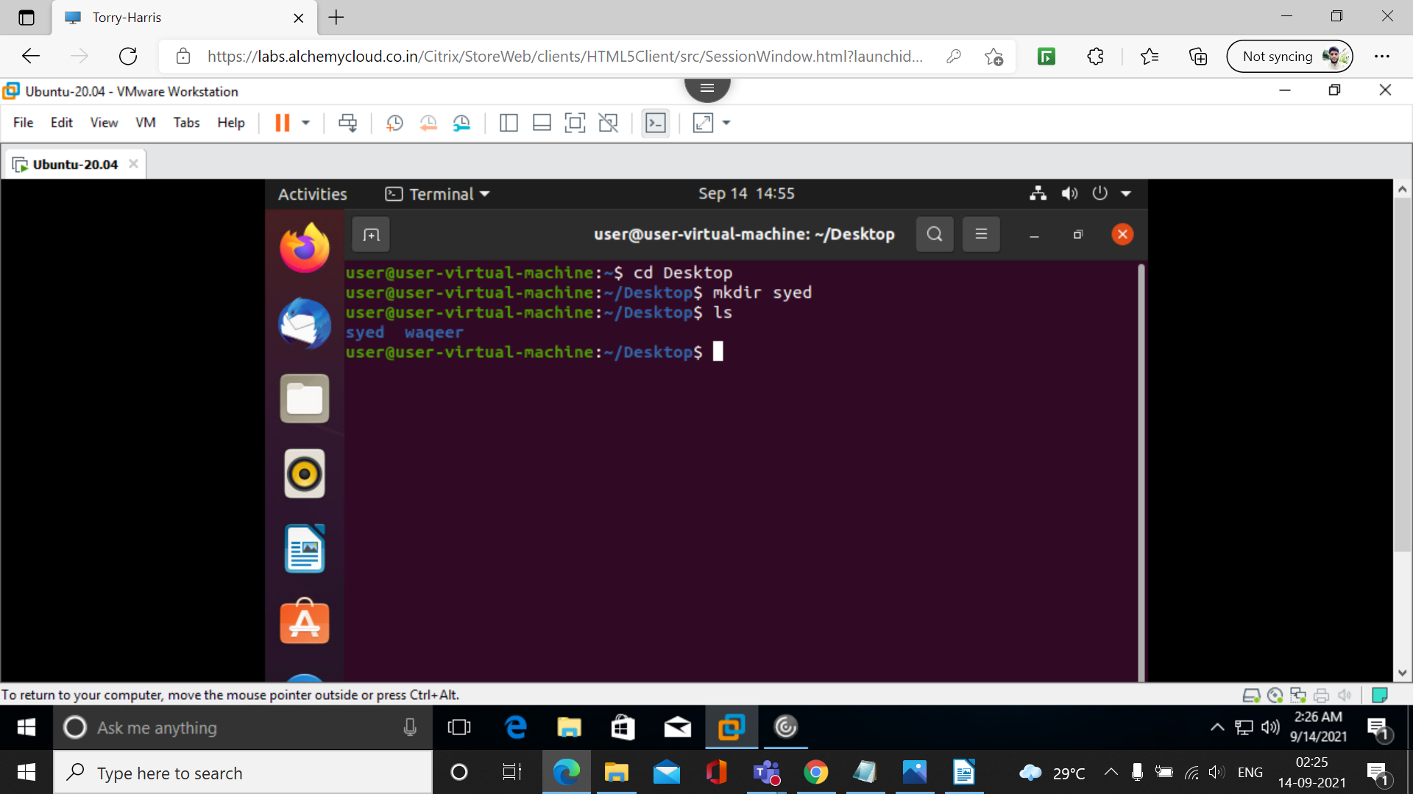

16. rmdir

rmdir command is used remove empty directories from the filesystem in Linux. The rmdir command removes each and every directory specified in the command line only if these directories are empty. So if the specified directory has some directories or files in it then this cannot be removed by rmdir command.

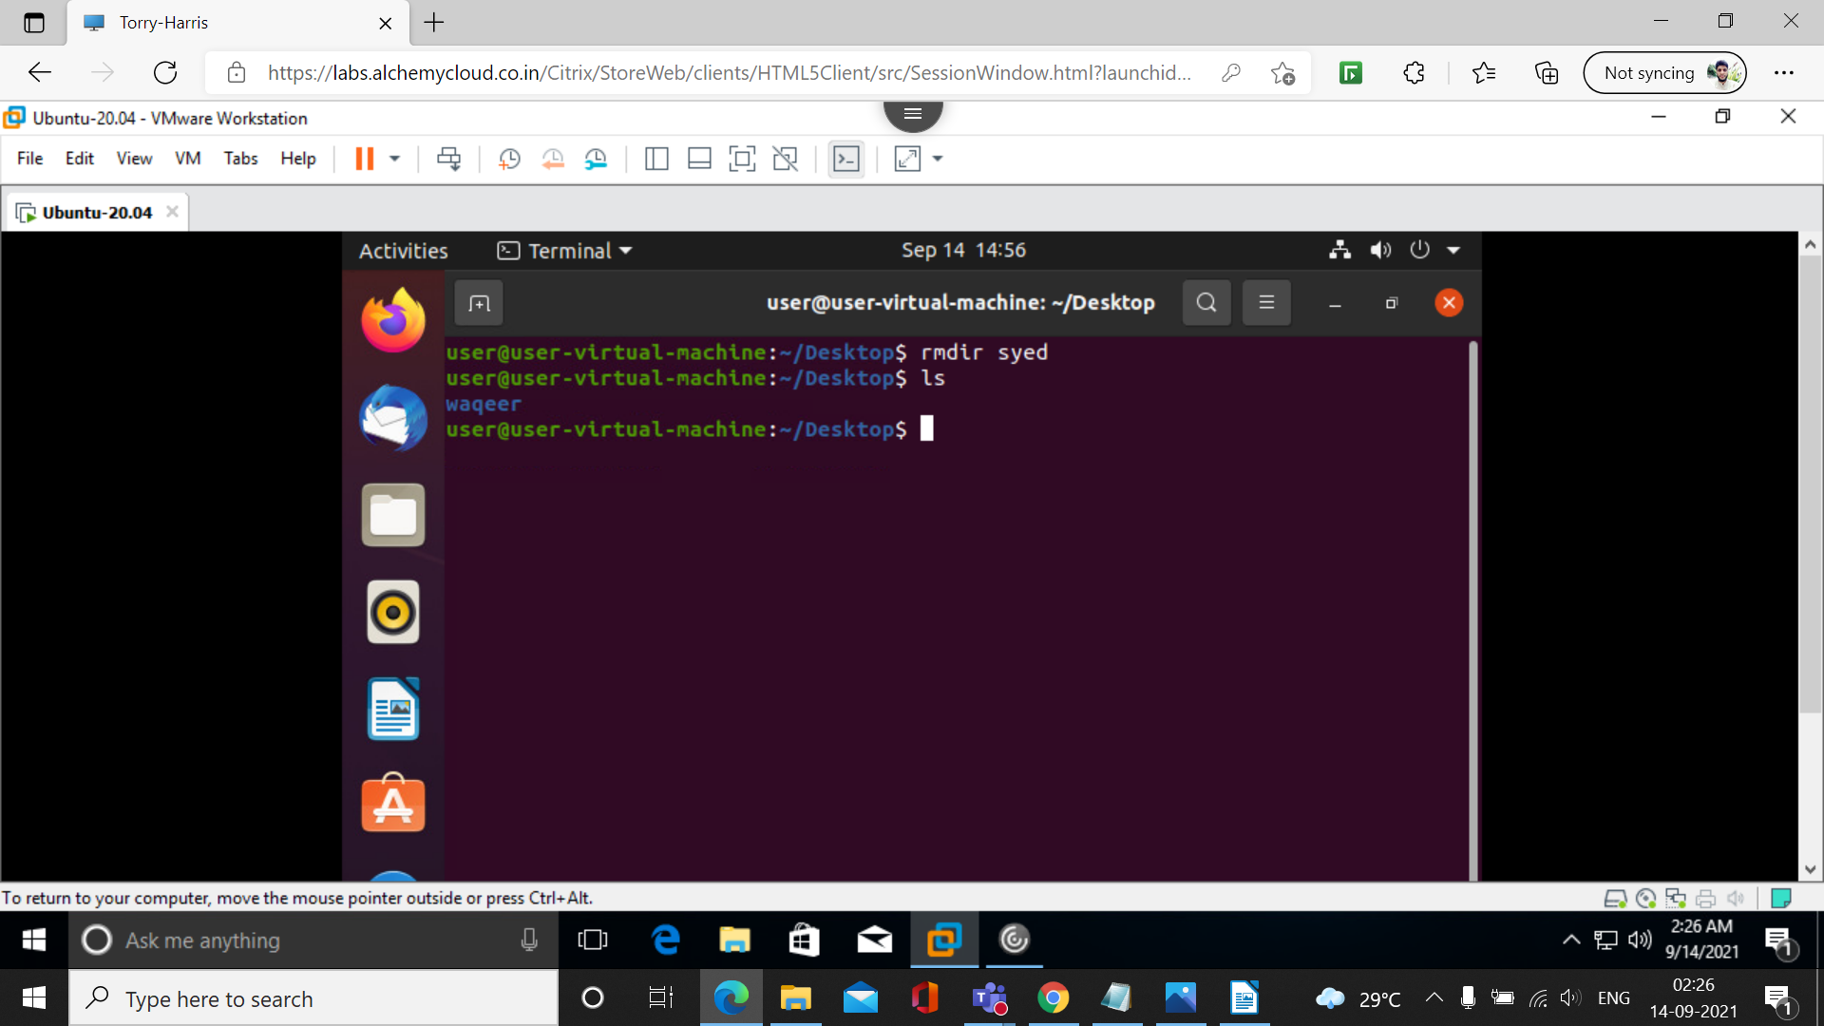
17. ls -A

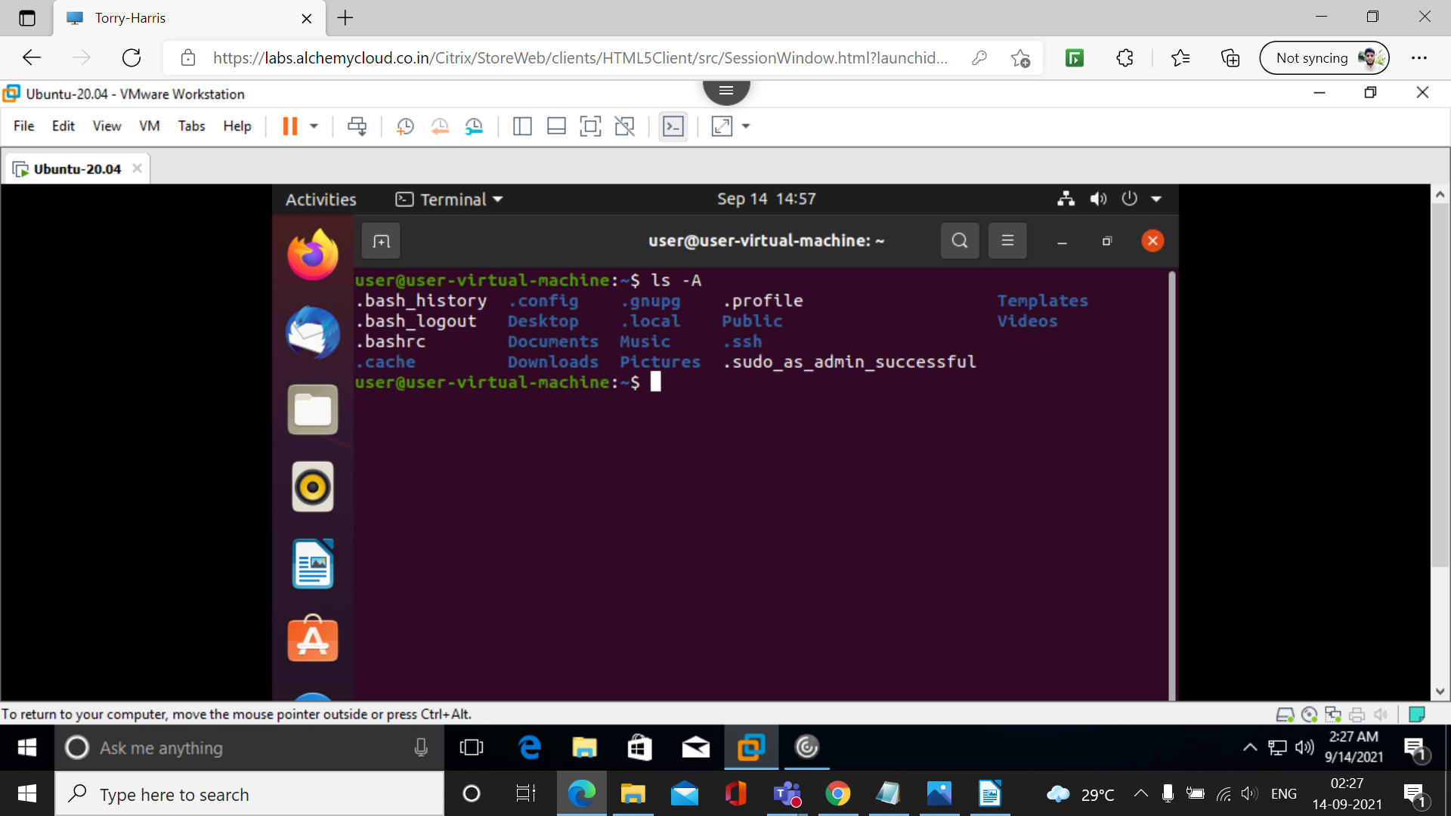
18. who

The Linux "who" command lets you display the users currently logged in to your UNIX or Linux operating system.
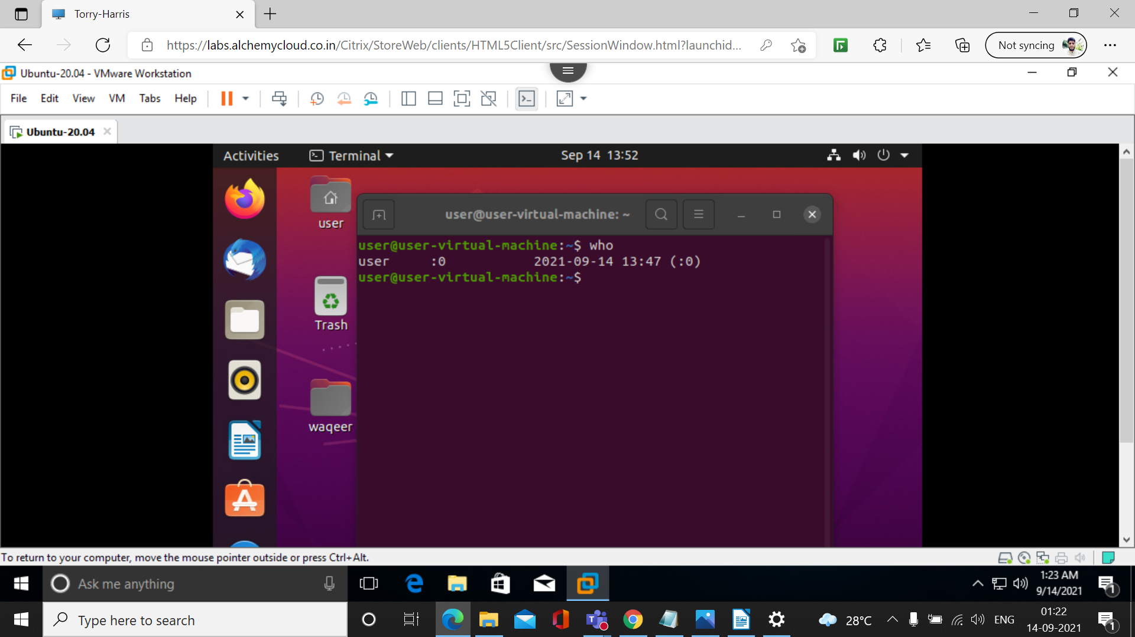

19. date
and is used to display the system date and time. date command is also used to set date and time of the system.
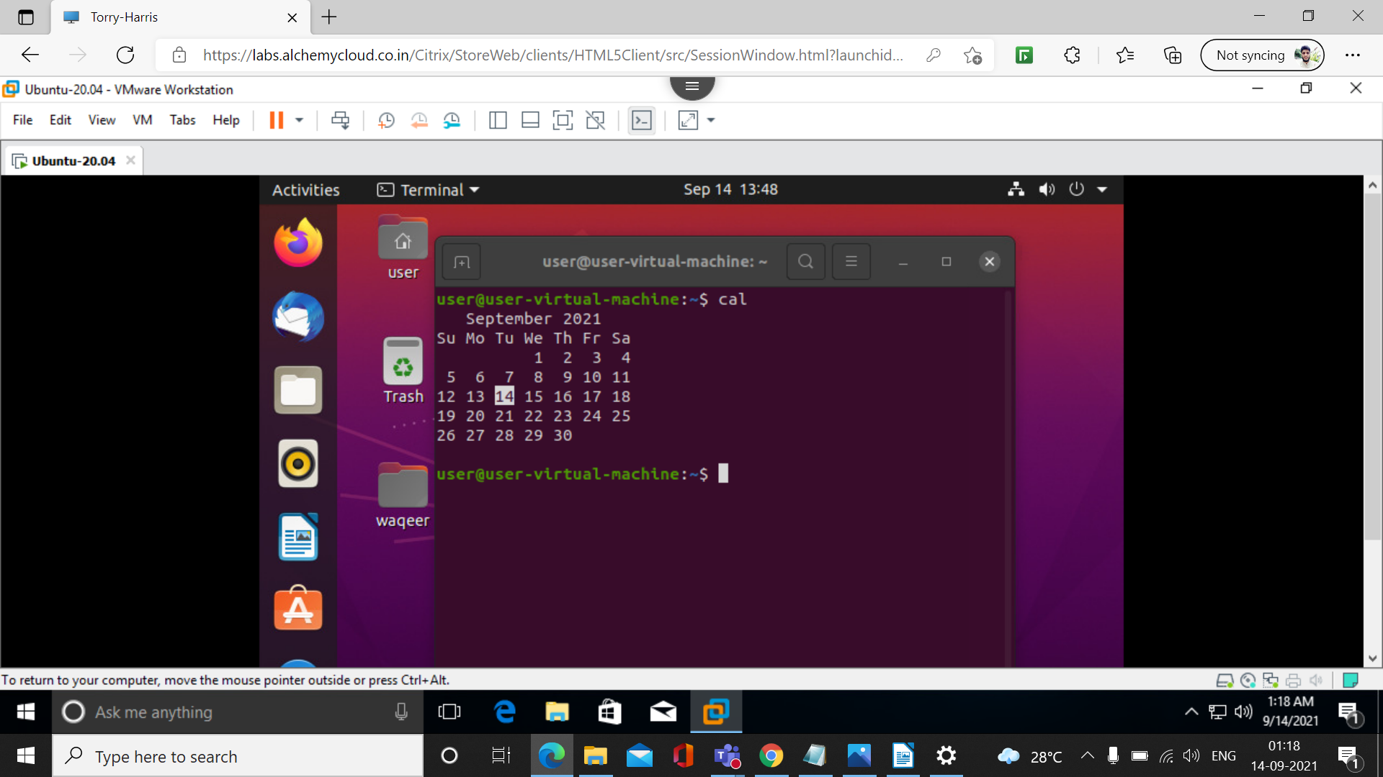

20. cal

The cal command displays a calendar of the specified year or month.
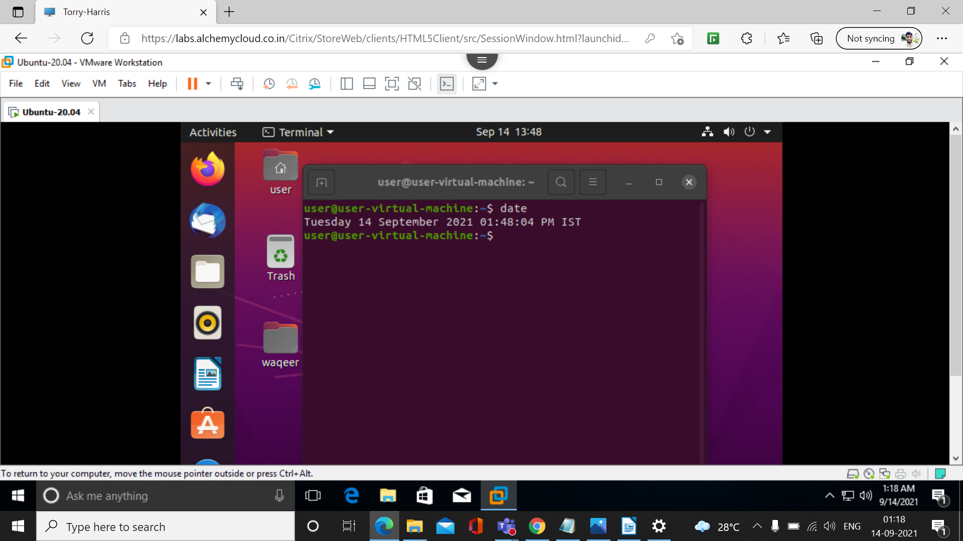

21. touch

It is used to create a file without any content. The file created using touch command is empty. This command can be used when the user doesn’t have data to store at the time of file creation.

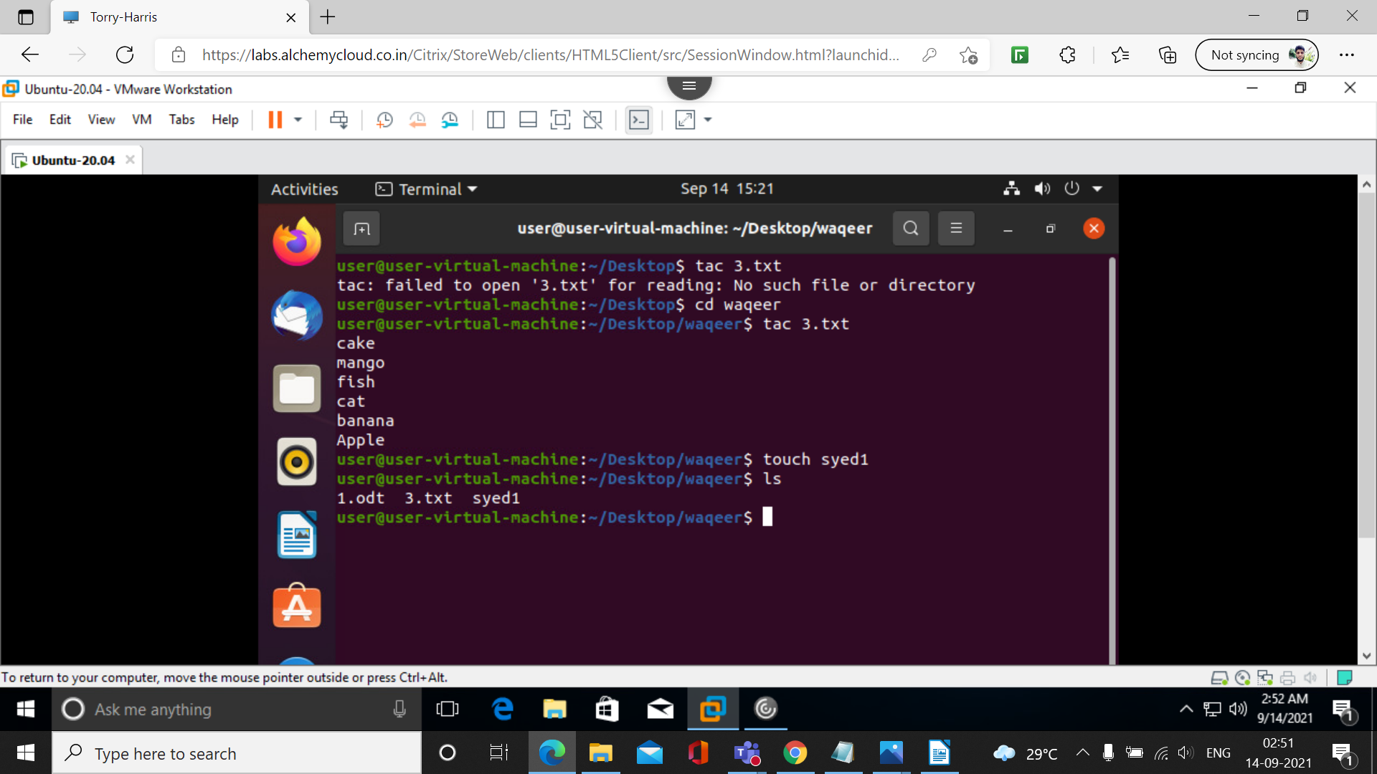

22. rm

The rm command is used to delete files.
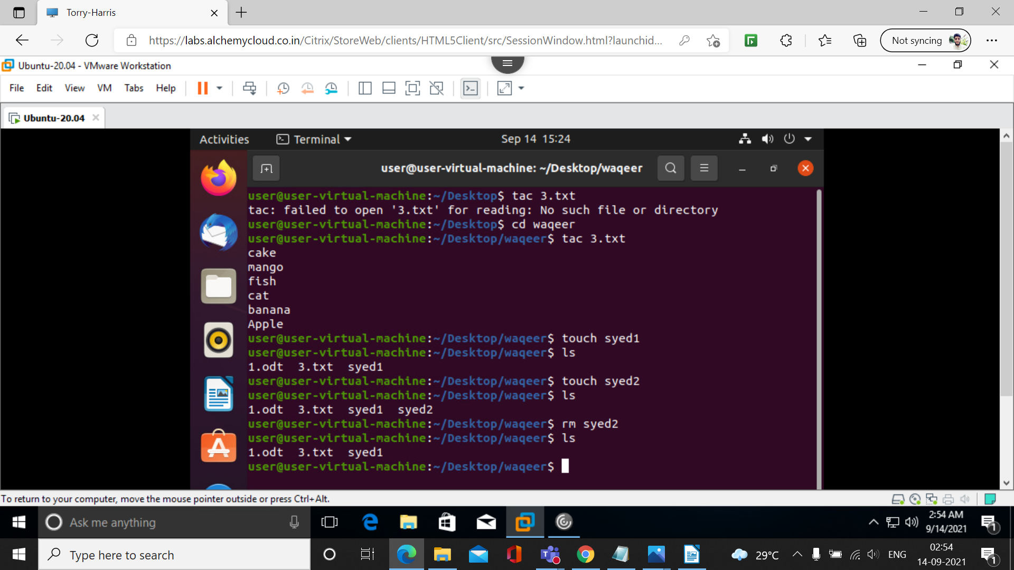

23. cp

The Linux cp command copies a file or a folder on a computer. You can move one or more files and folders at the same time. The syntax for cp is the name of the file to be copied followed by the place the copy should be located.
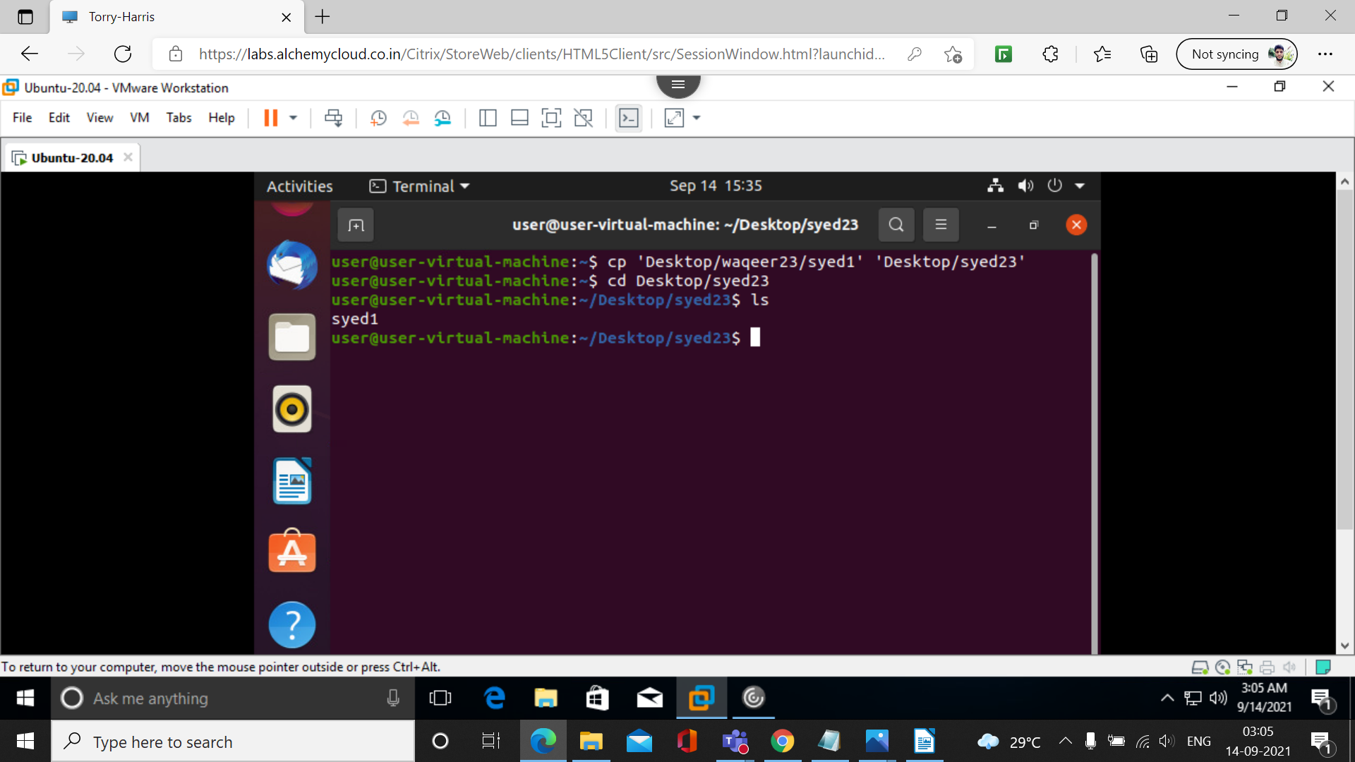
24. mv
mv command is used to move existing file or directory from one location to another.

25. tac
tac command in Linux is used to concatenate and print files in reverse. This command will write each FILE to standard output, the last line first
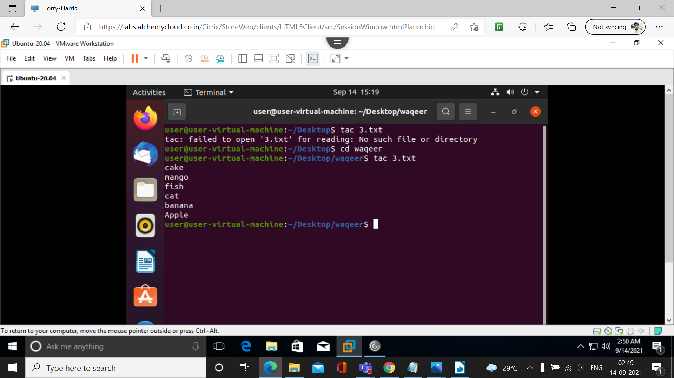

26. sort
The sort command is used in Linux to print the output of a file in given order. This command processes on your data (the content of the file or output of any command) and reorders it in the specified way, which helps us to read the data efficiently.
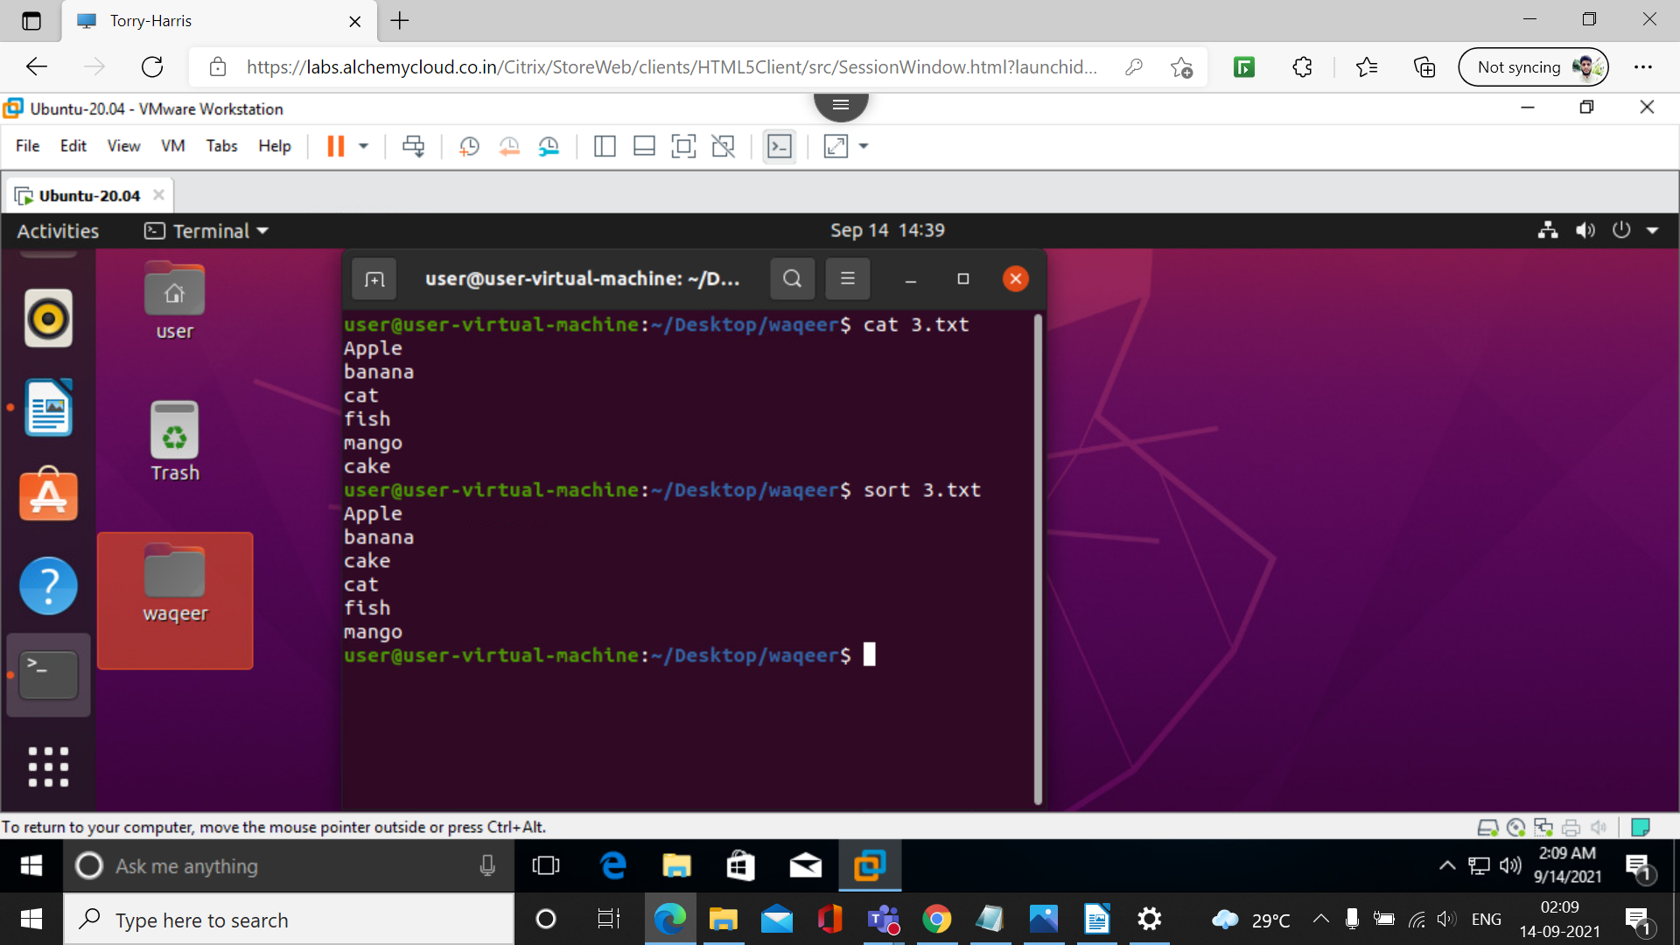

27. tree
Tree is a recursive directory listing program that produces a depth-indented listing of files. ... Upon completion of listing all files and directories found, tree returns the total number of files and directories listed.

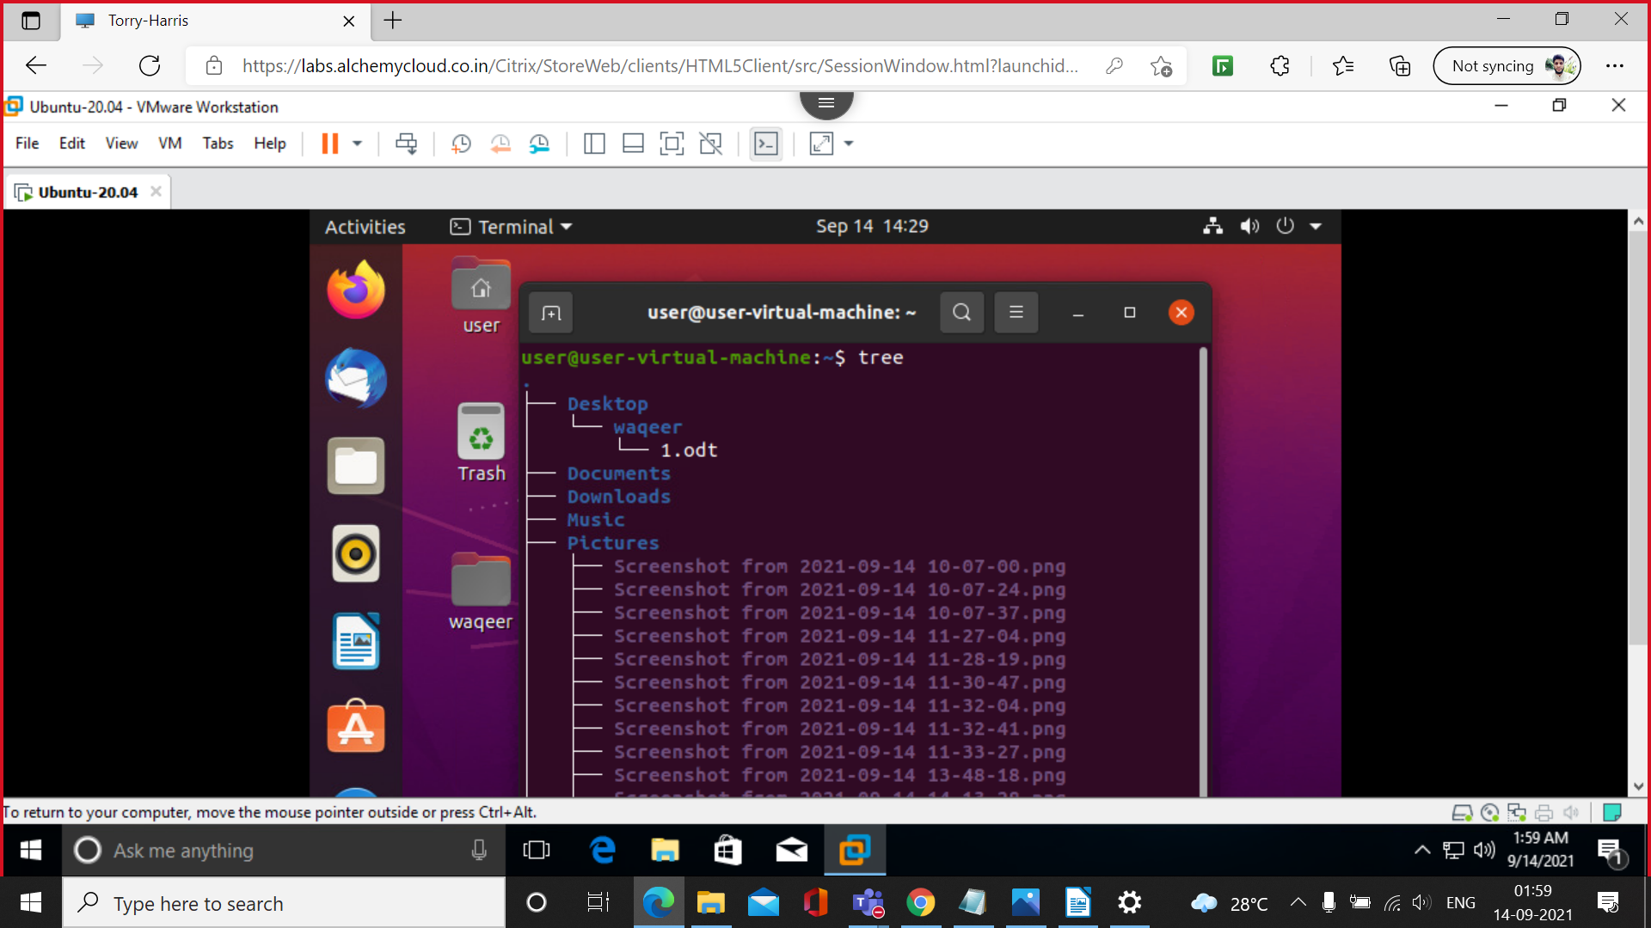

28. mkdir -p syed/2/3/4
This command is used to create file inside the another file.
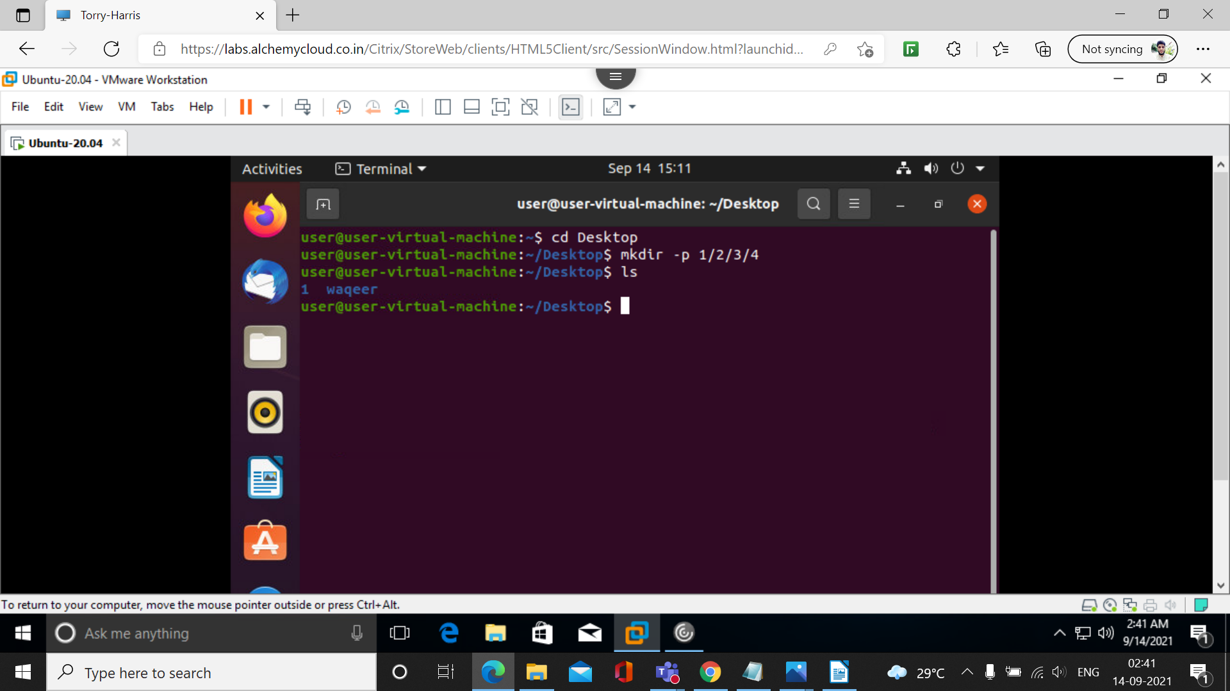
29. rn -rf filename

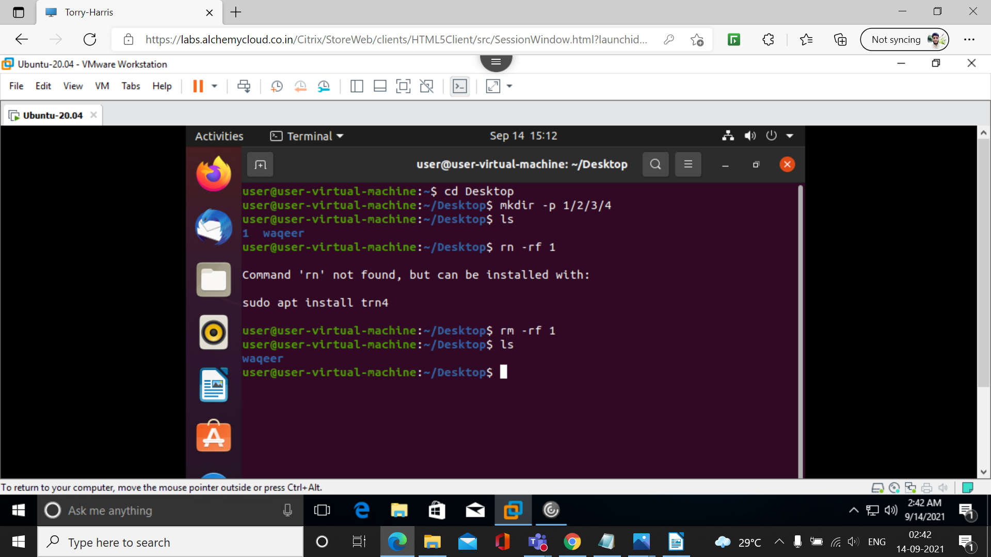

30. ls -lr

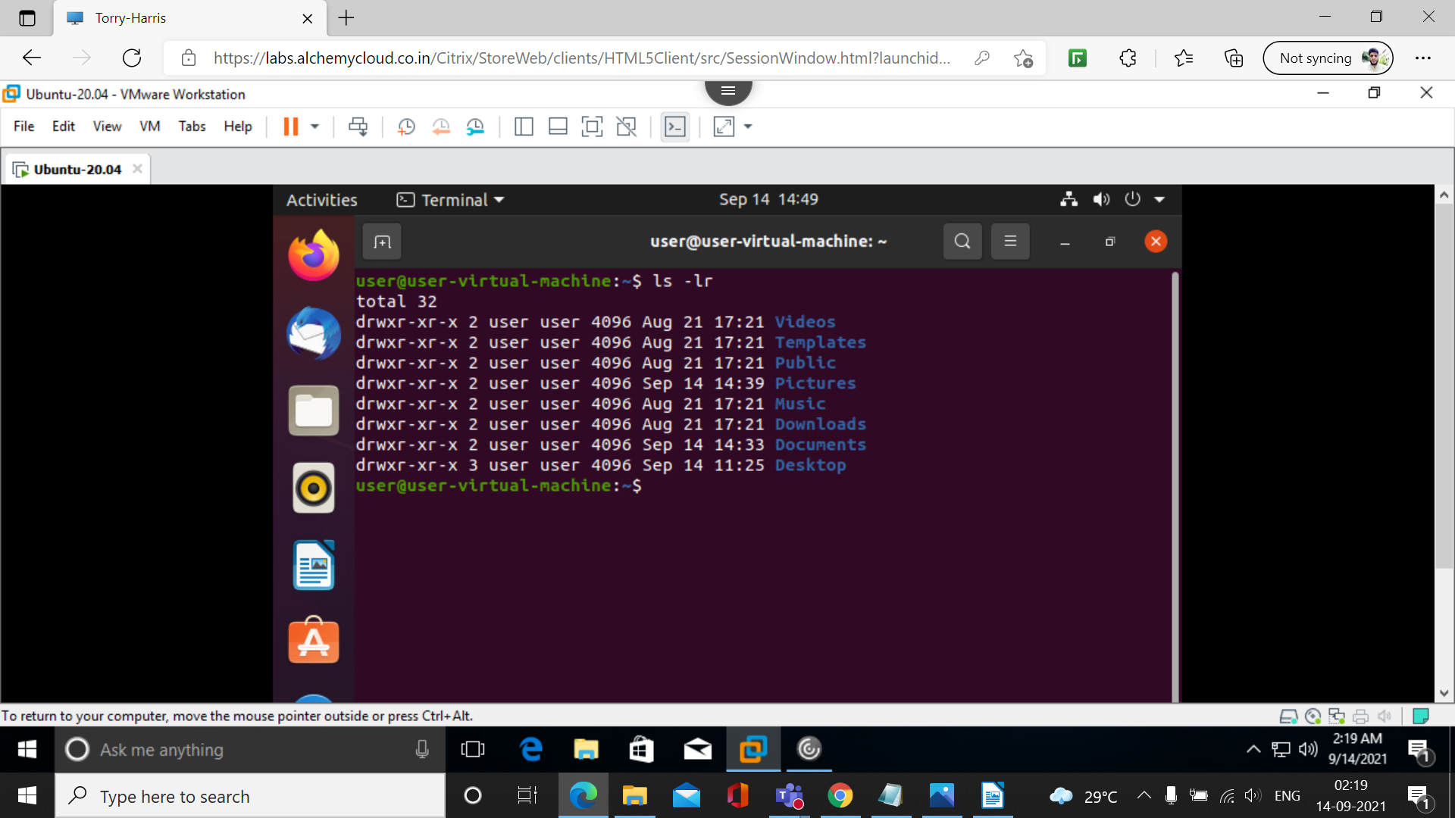

31. ls -l -a

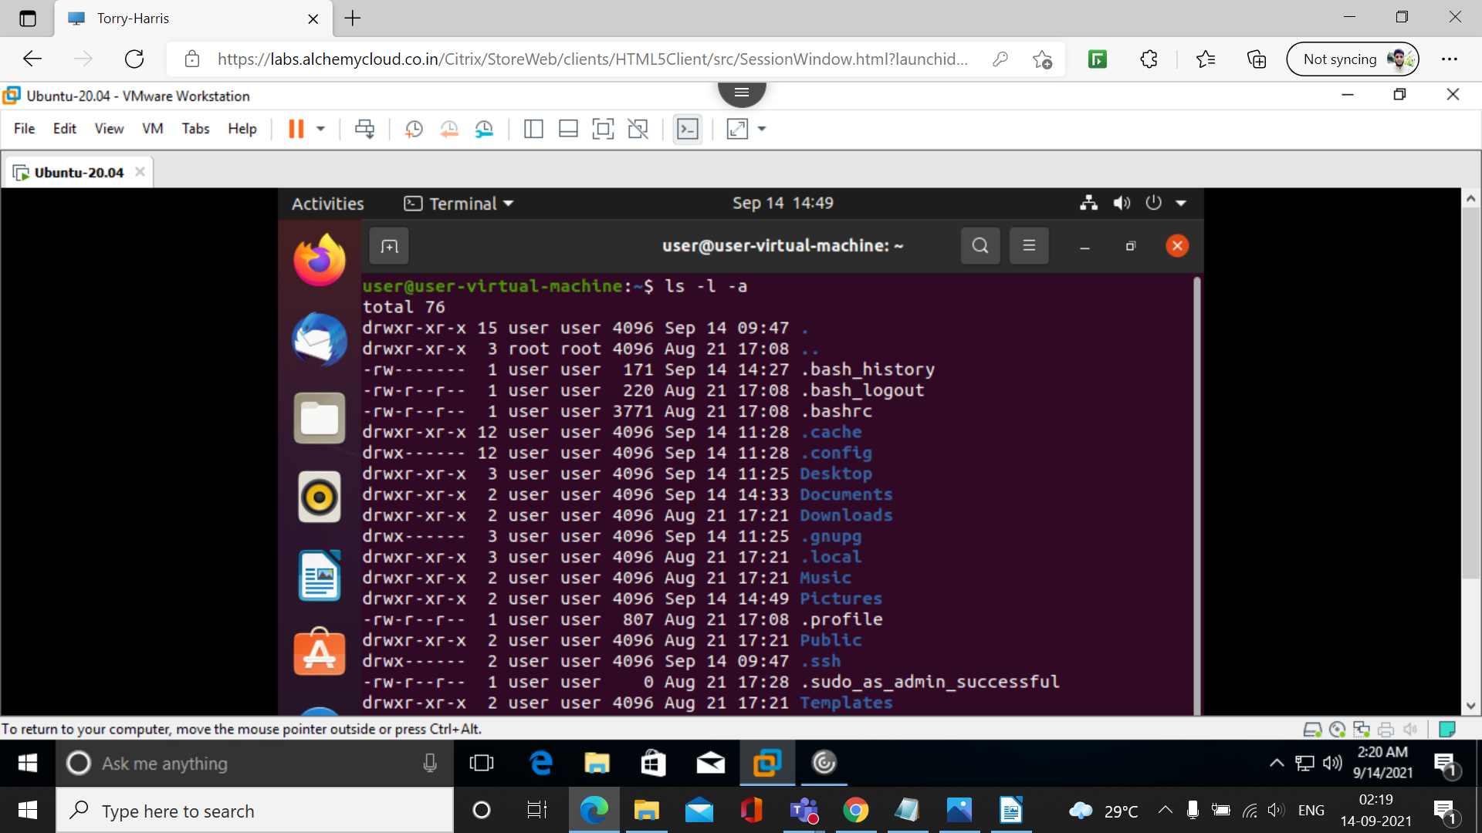

32. ls -l -a -r

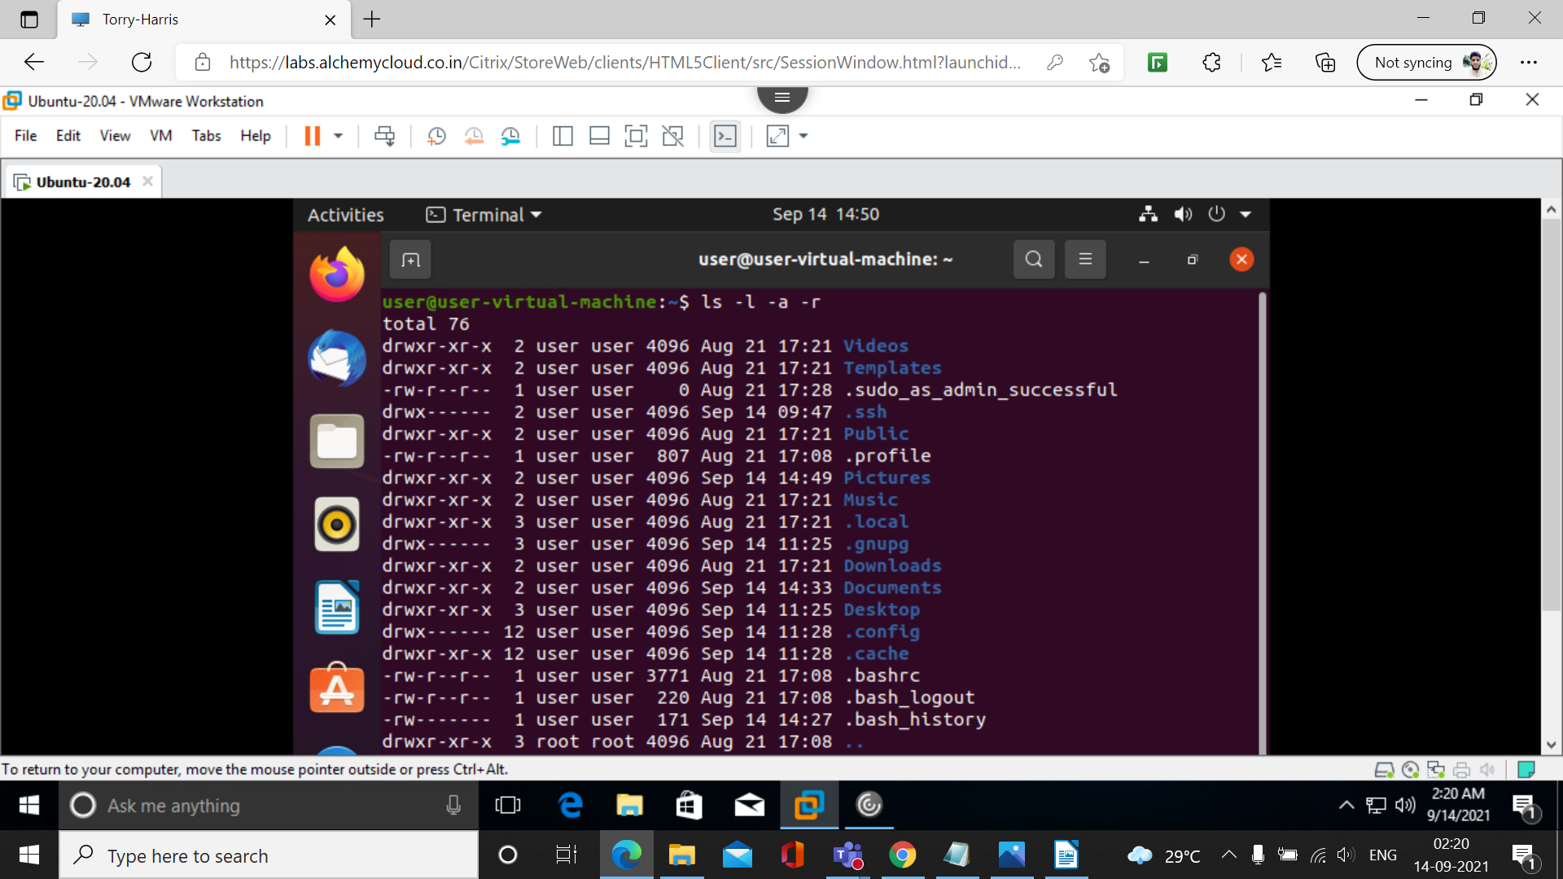

33. ls -lar

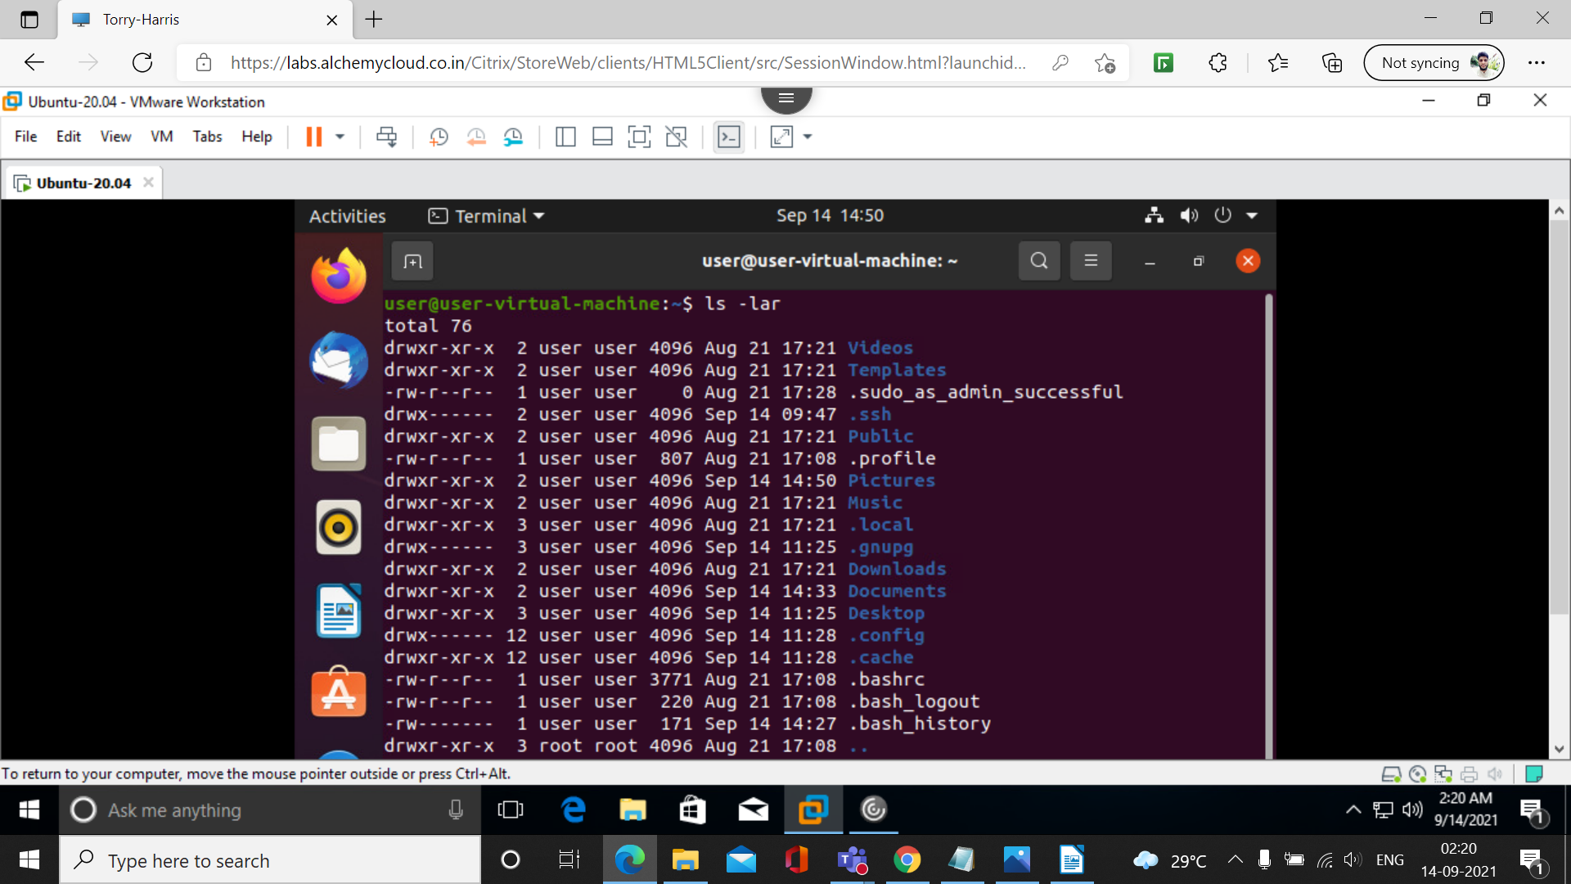

34. passwd
This command is used to change the password.

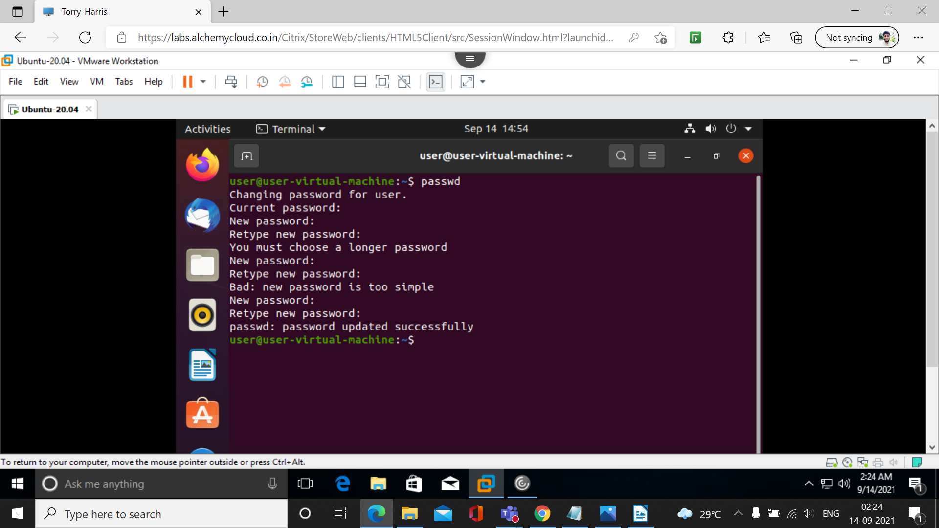

35. tree –help

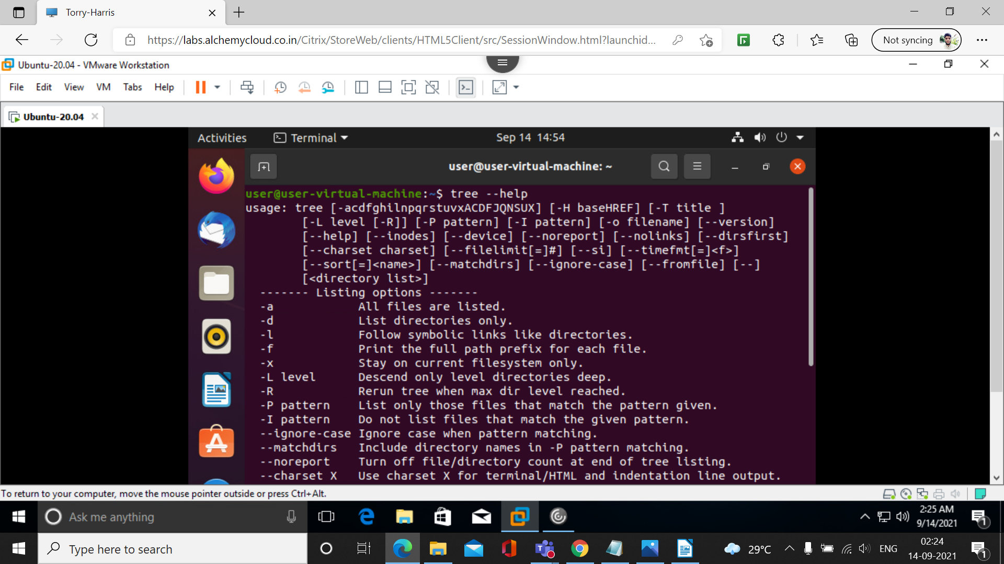

36. tree desktop
this command used to show files within the specified directory.


